Washington Square
Washington Avenue
La Plata, MD 20646

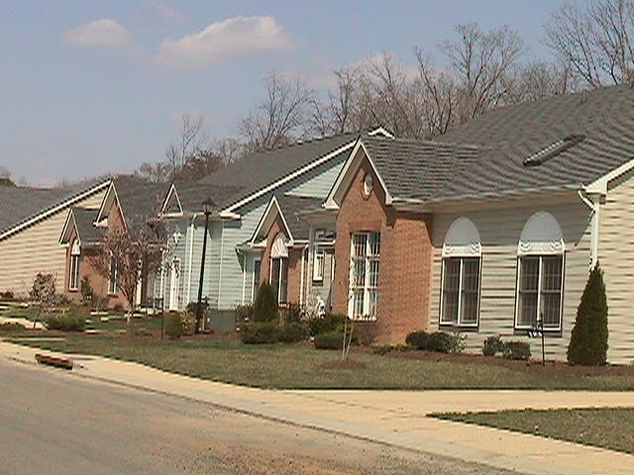

Join a variety of happy homeowners in La Plata, the heart of Southern Maryland. This sparkling community consists of one and two-story condominiums. New housing is planned for the future.

PROPERTY | Residential Condominiums
VACANCIES | Please call Bruce Davis, Inc. @ (301) 934-7102 for vacancy information.
ACCESSIBILITY | Conveniently located just off the Route 301 corridor, with easy access to I-495, D.C., and Northern Virginia.
AMENITIES | Only a few minutes from the hospital, library, Charles County Courthouse, and local restaurants and retail establishments.
CONDO SIZES | Please call Bruce Davis, Inc. @ (301) 934-7102 for condominium information.
CONDO PRICES | Please call Bruce Davis, Inc. @ (301) 934-7102 for sales information.

CONTACT: Allison Adams / (301) 868-2244 / adamsco@erols.com

