Sam's Shopping Center
3411 Branch Avenue
Temple Hills, MD 20748

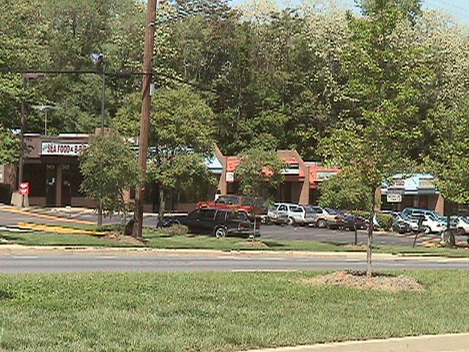

Join a variety of successful merchants and restaurants in this sparkling shopping plaza located just minutes from the Washington, D.C. line.

PROPERTY | Commercial Shopping Plaza
VACANCIES | 0
ACCESSIBILITY | Conveniently located just off Branch Avenue and only minutes from the D.C. line and a metro station.
AMENITIES | Located near the Census Bureau and Iverson Mall.
STORE SIZES | Stores available from 1,000 sq. ft.
RENTAL RATES | Competitively priced from $18.50 per square foot.

CONTACT: Allison Adams / (301) 868-2244 / adamsco@erols.com

